Evaluation measures
external evaluations: v-measure, completeness, homogeneity

Entropy of clustering H(C) and true labels H(K)
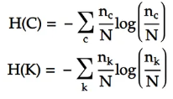
Conditional Entropy of true labels given the clustering H(C/K) and the Conditional Entropy of the clustering given the true labels H(C/K), n(ck) is the number of elements in cluster c with class k
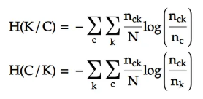
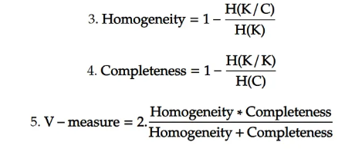
Internal Evaluation Measuremets
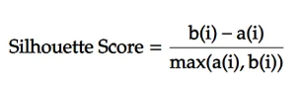
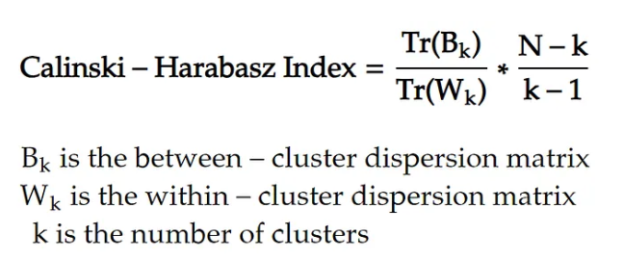

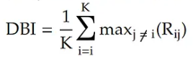

Homogeneity – measures whether each cluster contains ONLY data point that are members of the same class
Completeness – measures whether ALL datapoints that are members of a given class are assigned to the same cluster
V-measure - is the harmonic mean of homogeneity and completeness.
Entropy
counts variable – array of elemets which represent the number of datapoints in each cluster

Silhouette Score – measures how similar an object is to its own cluster (cohesion) compared to other clusters (separation)
a(i) - average distance between sample i and other points in the same cluster
b(i) – average distance between sample i and other points in nearest cluster

Davies-Bouldin Index – measure the average simiarity between each cluster and its most similar cluster, taking into account both the scatter within clusters and the separation between clusters
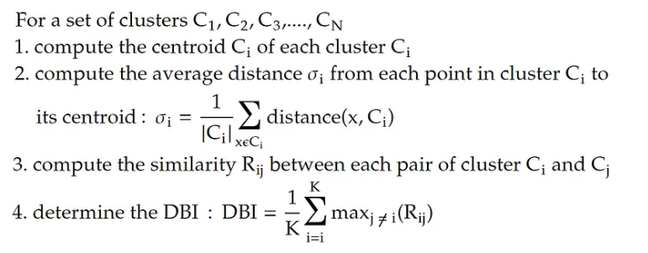
Calinski-Harabasz Index (Variance Ratio Criterion) - measures the ratio of the sum of between-cluster dispersion to within-cluster dispersion.

Yes, overfitting occurs in unsupervised learning as well
Overfitting means your algorithm is finding patterns in attributes that only exist in this dataset and don't generalize to new, unseen data. In addition to finding real patterns, when overfitting, the algorithm is also finding "patterns" that are only stochastic noise.
Example for clustering
For clustering this means the clusters you are finding only exist in your dataset and can't be seen in new data.
Your algorithm might find two clusters in the dataset that don't exist for new data, because both clusters are actually subset of one bigger cluster. Your algorithm is overfitting, your clustering is too fine (e.g. your k is too small for k-means) because you are finding groupings that are only noise.

